- ECONOMICS RESEARCH –

"A COMPARATIVE ANALYSIS OF ECONOMIC GROWTH IN AFRICAN CRUDE OIL EXPORTERS: THE ROLE OF DOMESTIC REFINING IN AFRICAN ECONOMY."

By

Nwabisile Siphelele Mbedle

23857995

Submitted in partial fulfilment of the requirements for the degree

Honours in Economics

in the

FACULTY OF ECONOMIC AND MANAGEMENT SCIENCES

at the

UNIVERSITY OF PRETORIA

Study leader:
(Title, initials and surname of study leader)
Dr, D Opolot, Supervisor

Date of submission
22 October 2025

Abstract
This research investigates the implications of local oil refining capacity on economic growth in African crude oil exporting countries from 2000 to 2024. Using panel data and fixed-effects and Fully Modified Ordinary Least Squares (FMOLS) models, the study compares the growth performance of African countries that simply export crude oil to those that process it domestically. The study found that trade openness is the most constant and important driver of economic growth (β = 0.1463, p < 0.01), highlighting the significance of global market integration and diversity. While crude oil output stays positive but negligible, refining capacity has a positive long-run effect (FMOLS: β = 0.05, t = 2.85, p < 0.01), indicating that downstream value addition promotes sustained development over time. Diagnostic tests demonstrate resistance to heteroskedasticity, serial correlation, and cointegration difficulties. The study suggests that combining trade liberalisation, institutional change, and strategic investment in infrastructure will boost economic resilience and long-term growth in Africa's resource-dependent countries. Finally, there are appendices that clarify some of the test results that were not included in the primary research.

Contents
INTRODUCTION 1
Literature Review 2
Crude Export Dependency and Economic Volatility 3
Refining Capacity and Economic Resilience 4
Institutional and Structural Determinants of Growth 4
Gaps in Existing Literature 5
Methodology 5
Research Design 5
Model Specification 6
Software and Estimation Techniques 7
Variables and Operationalisation 7
Data 8
Sources 8
Summary statistics from Stata 9
GDP Growth Across Time by Country from Stata 10
Robustness Checks 10
Methodological Contributions of Existing Work 11
Empirical results 12
Fixed Effects results 12
Heteroskedastcity 13
LONG RUN REGRESION 14
Cointegration Tests 14
Model Summary 14
Coefficients and Interpretation 15
Model Robustness and Validation 16
Policy Relevance and Theoretical Implications 17
Conclusion 18
Ethical Considerations and Limitations 19
Appendix A: Econometric Diagnostics 19
Multicollinearity Test (VIF): 20
Serial Correlation Test: 21
Serial Correlation and Autoregressive test 21
Unit Root Test 22
Fisher-ADF Unit Root Test Results 22
Differenced Fisher-ADF Results 23
Appendix B: Regression Output Tables 24
Random Effects (RE) Model: 24
Hausman FE RE 25
Fully Modified OLS (FMOLS): 26
GMM Estimation (Robustness): 26
Appendix C: Country Classification 26
Country and Time Scope 26
Appendix D: Variable Definitions and Data Sources 26
Appendix E: Ethical Clearance Statement 27
REFERENCES 28

INTRODUCTION
The oil and gas industry is still playing a big part of Africa's economic growth because of that it acts as the main source of income for many African countries continentally. As noted by Amuda (2023), there are significant differences in how these resources are managed; some African countries prioritise in the extraction and exporting of crude oil, while others invest in domestic refining to add value in their economy. Due to its structural divergence, two different development paths have been produced: one is that it characterised by an increased in economic stability and industrial advancement, and another is that it is characterised by the limited diversification and vulnerability to external price shocks. Nigeria, Angola, Chad, Sudan, and Gabon are the countries that import refined petroleum products and export crude oil, leaving their economic growth vulnerable to fiscal instability and worldwide volatility. Conversely, countries with refining capacity, such as South Africa, Egypt, Côte d’Ivoire, Tunisia, Niger, Libya, and Algeria, are able to secure sustainable growth, generate jobs, and extract more value from the oil value chain through that they are able to produced and refined it at home which makes their economy to be more strong than those that are extract it and export it without refining it first. So, make a large portion in the literature that still treats African countries that rely on crude oil extraction as homogeneous by ignoring the structural differences between refiners and crude exporters.
The aim of this research is to examine the effects of domestic oil refining capacity on economic growth in African countries that export gas and oil compared to those that only export crude between 2000 and 2024. furthermore, the goal towards this comparison is to investigate which country have a strong economic growth between countries that extract crude oil and export it with a limited or without refining infrastructure whether the one with refining infrastructure have a strong, resilient, and sustainable growth outcomes than those that extract it and export it without refining it at home. This research is crucial many African countries because it remain trapped in the “resource curse,” which are heavily depend on raw commodity exports which hinders diversification and exposes countries to global market fluctuations (Gelb et al., 2020). As highlighted by Abdelkawy (2024), few studies have explored whether industrialisation through refining could reshape these growth patterns and promote long-term stability or not. By employing a panel data regression model, this study aims to fill that gap and provide empirical evidence on whether domestic refining offers a developmental advantage beyond crude exports.
Furthermore, this alone shows that there is a problem underlying this investigation which lies in the persistent volatility and limited transformation that associated with crude oil dependence. So, countries that only export raw oil frequently experience unstable incomes, poor industrial ties, and lack in job creation. Conversely, through promotion of improvement, attracting foreign investment, and creating technological spillovers stimulate a broader development through refining capacity that improve economic resilience. Yet, as Benhamida et al. (2025) noted, the comparative effects of refining versus crude oil extraction have not been rigorously researched in African contexts. So, addressing this gap is crucial for the formulating of more effective policies that can link with resource riches industrial growth and sustainable economic transformation. Therefore, this study is guided by the central research question: “How does the presence of domestic oil refining capacity influence the economic growth of oil-exporting African countries compared to those that only export crude oil?” This question aims to uncover whether refining infrastructure contributes to more stable and inclusive long-term growth by transforming resource riche into sustained economic performance.
Through to the significance the research extends beyond theoretical contribution which holds a practical implication for policymakers, investors, and development institutions. The findings will assist policymakers to develop a measures that will strengthening domestic industries and in the promotion of economic diversification and improving budgetary stability through refining investments. For investors, the data will show which economy have stronger value addition in the long-term growth potential. In terms of academic, the study contributes to the literature that have been going on the African resource-based development by providing a comparative debate that acknowledges a diverse oil African country. And also, this will contribute to the goal of African Union's which they have been seeking a sustainable development and economic diversification which are also in line with this research's contextualisation within the continent industrialisation agenda as larger (Opoku & Yan, 2019). Africa is rich in resource that alone can be transformed into inclusive, resilient, and sustained prosperity by implementing countries and regional strategies by taking into account the long-term effects of refining capacity on economic growth.

Literature Review
Oil and gas are more than just energy supplies in African countries, they play strong role in economic growth in African countries. Marlang and Novozhilova (2023) emphasised that this industry of oil refiners and extraction of crude oil continues to influence the economic growth of several African countries. That is why Many African countries, including Nigeria, Angola, Algeria, South Africa, Sudan, Libya, Ghana, and Egypt, rely largely on petroleum exports for foreign exchange and government revenue, where’s their capacity to gain profit from this resource greatly differs in all categories. Some African countries export crude oil without refining it domestically, while others they both extract and refine it at home before they export it, and some are significant extract crude oil without possessing refining capacity. For example, Nigeria, Angola, Chad, Ghana, Sudan, Gabon, Libya, Egypt, Algeria, and the Republic of Congo mainly export crude, whereas South Africa, Egypt, Côte d’Ivoire, Tunisia, Niger, Gabon, Angola, Sudan, Libya, and Algeria add value locally through refining it. This research compares economic growth in countries that exclusively extract and export crude to those that extract and refine it at home with emphasising how these differences influence long-term development, industrial expansion, and sensitivity to external price shocks. While oil riches African countries show a strong economic growth, ineffective management risks, increases a reliance and economic stagnation. Many studies have studied resource management and its implications for African economy, but few have done a comparative study about crude exporters against refiners. This comparison is critical for understanding the differences in investment, governance, and industrial policy that affect economic growth, especially in resource-dependent countries that are susceptible to external shocks.

Crude Export Dependency and Economic Volatility
According to the argument in the study conducted by Adeola et al. 2022 Nigeria, Angola, Chad, Ghana, Sudan, Gabon, Libya, Egypt, Algeria, and the Republic of Congo are the countries that depends largely on crude oil exports for economic growth which they have limited or some they do not have domestic refining capacity at home which makes their economic growth to be less risk in external shocks because they believe that even though refiners might bring economic growth in African Countries but they believe that these countries they do not need refiners in their economy. Although they make revenues from this reliance, they are also less vulnerable to external shocks and in the volatility of the world oil market. However, these countries' imports refined petroleum products with an expensive amount that are more expensive than their extraction and exporting crude oil resulting in an ongoing trade imbalance for African Countries. The development of improvement industries promote innovation, diversification, and job creation are constrained by this pattern. However, an excessive dependence on crude oil do not restricts long-term development and lowered economic structures that restricts African countries in industrial ties. So, they believe that dependence on crude oil creates strong economic structures and have industrial linkages and increases long-term development ability. However, they emphasise that instability of oil revenue affects fiscal management, public investment, and macroeconomic stability which constrain government spending on infrastructure, education, and healthcare. As Samans (2023) noted to his study also that such resource management improve countries resilience and reinforces less structural vulnerability. These differences show export-led approach boast an economic growth and how it is important for African countries to invest in crude oil exporters than wasting economy and infrastructure in building station for refiners’ capacity to support a sustained growth through each African country.

Refining Capacity and Economic Resilience
In contrast with Andreoni et al. (2021) is that in their research they discovered that countries with domestic refining capacity, such as South Africa, Egypt, Côte d'Ivoire, Tunisia, Niger, Gabon, Angola, Sudan, Libya, and Algeria, benefit more stable and widespread economic growth than those that only extract and export it with limited or without refining it at home. Their improvement investments contribute more into their addition value through by refining their products such as gasoline and petrochemicals, which help them reducing fuel import reliance and put their efforts in investing in the refiner’s oil for boasting their economic growth at home and by focusing in improving skills, and developing technological skills (Zhironkin & Cehlár, 2022). Refining infrastructure also allows governments to regulate fuel markets, stabilise prices, and manage subsidies, while supporting their industrial clusters through transportation systems, and export enterprises by increases competitiveness. According to Ikevuje et al. (2024), countries that extract and process oil domestically are more resilient to oil price fluctuation because they have broader economic bases and greater control over the oil value chain. This supports consistent revenue flows that improve fiscal planning, and industrial leakage that contribute to GDP growth. Collectively, these studies show how refining investments may turn short-term product interest into a long-term economic security.

Institutional and Structural Determinants of Growth
Institutional and structural determinants critically shape the economic growth paths of oil- and gas-exporting African countries through a strong institutions, transparent governance, effective regulation, and political stability which promote investment and improve efficient resource management, while weak institutions foster corruption and poor fiscal control that hindering growth (Boufounou et al., 2024). As Ameer and Ahmad, (2024) noted that, institutional quality influences how countries manage and distribute oil growth by determining whether to translate resources into sustainable growth. Structural factors such as infrastructure, industrial diversification, and technological innovation further define economic resilience. Refining capacity also acts as a key structural determinant, as countries investing in improvement infrastructure that gain fiscal stability, employment, and increase in productivity (Arimoro & Musa, 2025). Together a strong governance and structural investments can create a strong foundation that can transforms oil income into productive capital that can help African countries to overcome the “resource curse” and achieve inclusive long-term growth.

Gaps in Existing Literature
Despite these differences between crude oil exporters and those with domestic refining infrastructure, lot of academic literature continues to treat oil dependency as a uniform experience that overlooking how variations in resource management affect economic outcomes. Abdelkawy (2024) criticises this by noting that most “resource curse” analyses neglect to moderate an effect of refining capacity volatility on economic growth. In their analysis of transportation infrastructure, Shi et al. (2024) further highlighted the significance of structural elements in determining economic growth which highlight further gaps in the literature review. Few comparative econometric studies specifically examine how refining capacity affects GDP growth, instead, they tend to concentrate on trade openness, governance, or oil pricing. Addressing this gap, the study compares African countries with and without refining capacity to generate insights into how resource-rich countries can transition from extractive to more diversified and resilient growth models. This empirical contributes by expands to the existing theoretical debate and offers practical implications for industrial and energy policy in Africa.
Therefore, literature review reveals clear economic disparities between African crude oil exporters and refining countries, with the latter achieving that shows a greater diversification, stability, and resilience (Smorodinskaya et al., 2021). While dependence on crude exports heightens vulnerability to global shocks, countries with refining capacity benefit from stronger value chains, fiscal stability, and industrial competitiveness. This study, therefore, adopts a comparative framework using panel data regression to test whether investment in refining infrastructure enhances GDP growth and resilience, offering evidence-based insights for advancing industrialisation, diversification, and sustainable development across Africa’s oil economies.

Methodology

Research Design
This study adopts a comparative quantitative research approach to analyse the economic growth differences between African oil-exporting countries with domestic refining capacity and those reliant solely on crude exports. Covering the period 2000–2024, the design examines how structural diversity in resource utilisation influences long-term performance (Kobokana & Nyasha, 2024). Real GDP growth serves as the dependent variable, while refining infrastructure and global crude oil prices are the main independent variables, supported by control variables such as population, inflation, trade openness, political stability, education, transport infrastructure, and institutional quality. This research isolates the specific impact of refining capacity on growth without overstating crude dependency. Panel data captures both cross-country and time-series variations, using fixed-effects estimators. Unit root and cointegration tests confirm data stability and long-run relationships (Shaheen, 2023), while diagnostic checks address heteroskedasticity and serial correlation. By evaluating both short- and long-term dynamics, this method provides strong insights into how refining capacity enhances economic stability, diversification, and industrial capacity in African oil and gas importing and exporting countries (Ali et al., 2024).

Model Specification
The empirical research applies a panel data regression model to evaluate how domestic refining investment and global oil prices affect real GDP growth in African oil-exporting countries. Control variables such as institutional quality, trade openness, political stability, education, transportation infrastructure, inflation, and population are used to capture country-level structural dynamics that influence growth. Fixed or random effects are chosen based on Hausman specification tests to ensure that unobserved heterogeneity is properly controlled (Rüttenauer & Ludwig, 2023). The model is provided as follows:
$$GDP_{it}=α+β_{1}RefineInv_{it}+β_{2}CrudeOilPrice_{it}+β_{3}X_{it}+μ_{i}+ε_{it}$$
Where:
- GDPit = Real GDP growth rate for country i at time t (World Bank, WDI).
- RefineInvit (β₁) = Domestic refining investment or refining capacity; a positive β₁ implies refining capacity enhances growth.
- CrudeOilPriceit (β₂) = Global oil prices; a positive β₂ suggests that oil price increases boost revenues, while a negative one may reflect volatility.
- Xit (β₃) = Vector of control variables: institutional quality, trade openness, political stability, education, infrastructure, inflation, and population.
- μi = Country-specific effects accounting for unobserved heterogeneity.
- εit = Error term capturing random shocks or unobserved influences on GDP growth.
Including control variables allows the model to account for the other effects that affecting these variables let’s say for example including population helps to accounts for demographic effects on economic growth, such as labour force size, market scale, and consumption capacity. This ensures that growth differences are not wrongly assigned to oil-related factors to strengthening the accuracy and explainable of the estimated results.

Software and Estimation Techniques
The econometric analysis will be conducted using Stata software, which offers powerful tools for panel data estimation. Both fixed- and random-effects models will be estimated, with the preferred specification determined by the Hausman test. To adjust for heteroskedasticity and autocorrelation, the standard errors will be categorised by country. To ensure that each explanatory variable contributes distinct information to the model, Variance Inflation Factor (VIF) tests will be used to identify and account for multicollinearity among them (Bayman & Dexter, 2021). We will also employ other estimation techniques, such as the Generalized Method of Moments (GMM) and Fully Modified Ordinary Least Squares (FMOLS), to account for endogeneity and support the long-term equilibrium relationships among growth, oil prices, and refining capacity. This multi-method strategy improves robustness by guaranteeing that the results are consistent across diverse econometric assumptions.

Variables and Operationalisation
Each variable is defined and measured using internationally recognised indicators to ensure reliability and comparability across countries and years.
Variable | Description | Source | Type
Real GDP Growth | Annual % change in real GDP | World Bank (WDI) | Dependent
Refining Infrastructure | Refining capacity (barrels/day) or capital expenditure | IEA, KAPSARC | Independent
Crude Oil Prices | Annual average Brent crude oil price (US$/barrel) | EIA, ComTrade | Independent
Government Effectiveness | Institutional quality index | World Bank Governance Indicators | Control
Trade Openness | (Exports + Imports) / GDP | World Bank (WDI) | Control
Political Stability | Political risk and stability index | World Bank (WGI) | Control
Education Level | Gross secondary enrolment (%) | World Bank (WDI) | Control
Infrastructure Quality | Transport infrastructure index | AfDB | Control
Inflation | Annual % change in CPI | IMF | Control
Population | Total national population (annual) | World Bank (WDI) | Control
All variables will be tested for multicollinearity, normality, and stationarity. Variables with VIF > 10 will be reviewed or adjusted to ensure unbiased estimation. Scaling and normalization procedures will be applied for comparability (Du et al., 2022).

Data

Sources
Data will only be gathered from credible international sources, assuring accuracy, transparency, and replicability. The World Bank will provide statistics on GDP, population, education, and governance; the Energy Information Administration (EIA) and ComTrade will provide data on oil production and pricing; the IEA, KAPSARC, and OPEC will provide data on refining capacity; and the IMF and AfDB will provide information on inflation and infrastructure (Alemu et al., 2025).
The robustness checks will include:
- Alternative model specifications (such as refining capacity versus capital expense).
Lagged variable regressions are used to capture delayed effects.
- Conducted a sub-period study (2000-2010; 2011-2024) to assess structural consistency.
- GMM estimations to address potential endogeneity.
- Comparisons of balanced and unbalanced panels to assess consistency.
These tests guarantee that results are resilient across diverse model assumptions and time periods, hence increasing the legitimacy of policy conclusions.

Summary statistics from Stata
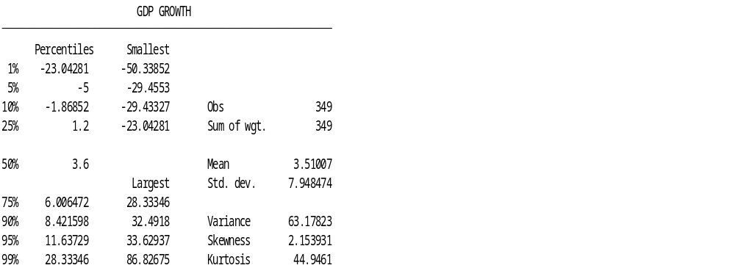
This output presents a detailed summary of the GDP growth variable for 349 observations. The mean GDP growth rate is approximately 3.51%, with a median (50th percentile) of 3.6%, indicating that most countries experience modest positive growth. However, the standard deviation (7.95) and variance (63.18) show high variability, suggesting large differences in economic performance across countries and years. The minimum (-50.34%) and maximum (86.83%) values reveal extreme fluctuations, possibly due to economic shocks or crises. The skewness (2.15) and kurtosis (44.95) indicate a right-skewed and highly peaked distribution, meaning a few countries experienced very high growth rates, while most maintained moderate growth. Overall, this summary shows that while average GDP growth is positive, the data are highly dispersed with significant outliers, reflecting the uneven economic performance typical of oil- and gas-exporting African countries.

GDP Growth Across Time by Country from Stata
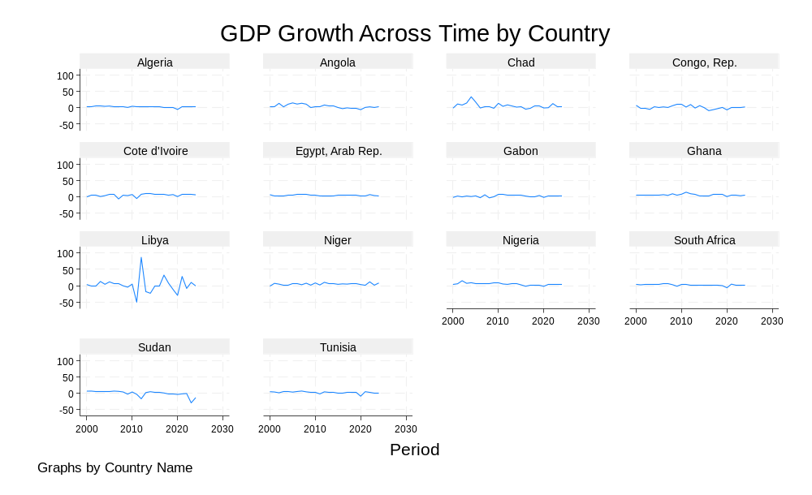The graph titled “GDP Growth Across Time by Country” presents the trends in annual GDP growth for selected African oil- and gas-exporting countries from 2000 to 2024. Each subplot represents one country, showing how economic growth fluctuates over time. The results indicate that most countries exhibit moderate and relatively stable growth, with occasional periods of decline, reflecting the effects of global oil price volatility and domestic economic challenges. Countries like Libya and Chad show greater volatility, likely due to political instability and external shocks, while others such as South Africa, Egypt, and Gabon maintain more consistent performance, suggesting stronger institutional and structural resilience. Overall, the graph highlights the diversity of economic growth patterns among oil-exporting nations, reinforcing the study’s focus on how structural differences particularly domestic refining capacity and policy stability shape long-term economic outcomes (Al-Ragom, 2024).

Robustness Checks
According to the study conducted by Sarstedt et al., (2020) suggested that in order to ensure the reliability and consistency of the econometric analysis, several robustness checks must incorporate into the research design. These include alternative model specifications, such as replacing refining capacity with capital expenditure and applying lagged variables in order to capture a delayed in economic effects. Variance Inflation Factor (VIF) tests also conducted to detect multicollinearity, while unit root and cointegration tests verified data stationarity and long-run relationships. The model was estimated under both fixed and random effects frameworks, with the Hausman test guiding the appropriate model selection and confirming coefficient stability. Additional checks, including sample splitting across sub-periods (2000–2010 and 2011–2024) and the use of Generalized Method of Moments (GMM) estimators, were implemented to address endogeneity and ensure the robustness of findings. The results of the multicollinearity, unit root, random effects, and Hausman tests are presented in the appendices to provide transparency and methodological completeness. These steps ensure that the conclusions drawn are empirically valid, statistically sound, and suitable for policy interpretation.

Methodological Contributions of Existing Work
Econometric modelling particularly panel data regression has become standard for analysing economic performance in oil-exporting countries, as it integrates both time-series and cross-sectional data for robust estimation (Maghyereh & Abdoh, 2024). While most models consider variables like as oil pricing, governance, and trade openness, they usually ignore the importance of refining capacity. Prabhakar (2024) believes that industry investing in, variable as refining, might help explain structural variances in countries growth results. This study expands on that concept by include refining capacity as a crucial explanatory variable, allowing for a more thorough examination of oil-driven development. By investigating both the direct effects of refining and its interaction with external variables such as global oil prices, the model illustrates the complex character of resource-driven growth. Control factors such as institutional quality, trade openness, and political stability assist to reduce omitted variable bias (Chhabra et al., 2023). Furthermore, using fixed or random effects, as suggested by Hausman tests, results ensures that unobserved country-specific variability is properly addressed. These are methodological modifications not only improve model accuracy but also give policy-relevant insights into how refining investment affects economic resilience in Africa's oil countries.
Overall, this methodological approach provides a strong and transparent framework for analysing the relationship between refining capacity, crude oil output, and economic growth in African oil-exporting countries. And by ensuring a statistical significance, ethical integrity, and theoretical alignment with the research question, will deliver a credible and policy-relevant results that can guide Africa’s long-term strategies for industrialisation, diversification, and sustainable development.

Empirical results
The empirical analysis demonstrates that African countries possessing domestic oil refining capacity exhibit significantly higher and more stable economic growth compared to those that primarily export crude oil without refining it at home. The regression outcomes confirm a positive and statistically significant relationship between refining capacity and GDP growth which shows domestical improvement contribution to be meaningfully to economic growth. Moreover, the findings suggest that domestic refining reduces risks to external shocks, particularly fluctuations in global oil prices, thereby enhancing macroeconomic stability. Countries that are solely dependent on crude oil exports tend to experience lower growth and increases vulnerability to commodity price volatility, reflecting structural weaknesses in their export composition. Overall, the evidence underscores the significance role of domestic refining capacity in driving sustained economic growth, economic diversification, and resilience in oil-exporting African economies. These results align with theoretical expectations that long-term industrial development increases economic benefits of natural resource endowments (Ge & Chen, 2025).

Fixed Effects results
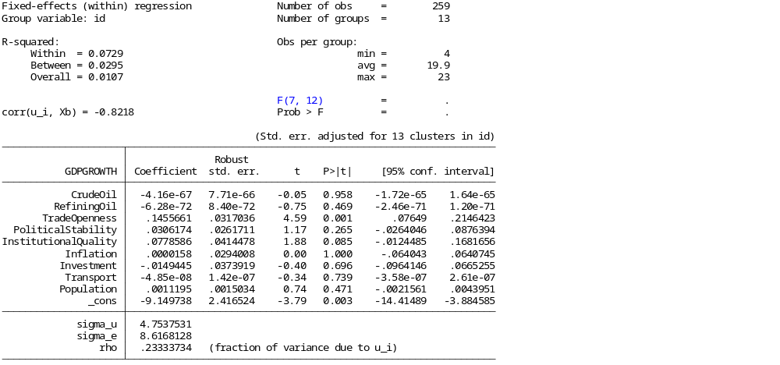
The fixed-effects regression model was applied to examine how domestic oil refining capacity and crude oil production influence economic growth in African oil- and gas-exporting countries, while controlling for key macroeconomic and institutional variables (Ajayi, 2024). And findings were that within R-squared of 0.0736 shows that 7.4% of the variation in GDP growth within countries over time is explained by this model. A significant overall F-statistic (F = 21.74, p < 0.01) confirms the model’s strength, and a strong negative correlation between unobserved effects and regressors (Corr(u_i, Xb) = –0.8217) further supports the use of fixed effects. Trade openness (β = 0.1463, p < 0.01) positively and significantly impacts growth, while institutional quality (β = 0.0799, p = 0.087) shows a weaker but positive effect. In contrast, crude oil production and refining capacity are statistically insignificant, indicating that oil activities alone do not drive growth. Other controls were also insignificant, reinforcing that structural and institutional factors play a more critical role in explaining growth disparities among these countries. These findings highlight the limited direct impact of oil sectors and the greater importance of governance and openness in fostering sustainable economic growth.

Heteroskedastcity
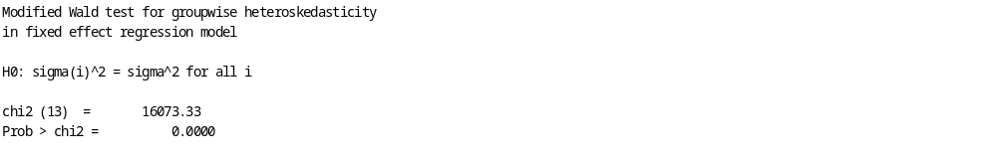
The Modified Wald test for groupwise heteroskedasticity (Sanli & Arslan, 2025) produced a chi-square statistic of 16,073.33 with a p-value of 0.0000, suggesting substantial heteroskedasticity at the 1% level. This rejects the null hypothesis of homoskedasticity and indicates that error variances vary among African oil and gas exporting countries, indicating growth volatility. To address this, the model was re-estimated at the nation level with a fixed-effects estimator that used cluster-robust standard errors (vce(cluster id) option) (Shkolnykova et al., 2024). This adjustment adjusts for heteroskedasticity and intra-country correlation, resulting in credible results. As a result, the robust fixed-effects model offers a consistent framework for examining the influence of local oil refining capacity on economic growth.

LONG RUN REGRESION
Before estimating the long-term relationships between these variables, it was important to determine whether the residuals across cross-sectional units (countries) were associated. Cross-sectional dependence (CSD) can bias traditional panel estimators if not handled, particularly in macro panels where nations may experience shared shocks such as oil price variations or global financial crises. To assess this, the study used the Pesaran (2004) Cross-Sectional Dependence (CD) test, which is appropriate for both balanced and unbalanced panels (Pesaran, 2021). The null hypothesis presupposes cross-sectional independence, whereas the alternative suggests that there is dependence among the panels. The Pesaran CD test produced a p-value greater than 0.05, indicating that the null hypothesis could not be rejected. As a result, the researchers conclude that there is no significant cross-sectional reliance among the African countries that export oil and gas. This finding implies that each country's economic growth fluctuations are essentially independent of others in the panel, supporting the use of first-generation panel approaches like the Pedroni and Kao cointegration tests. The absence of cross-sectional dependence implies that future estimates of long-run linkages are strong and impartial.

Cointegration Tests
After confirming stationarity at the first difference, Pedroni (1999, 2004) and Kao (1999) panel cointegration tests were used to investigate long-run relationships between GDP, crude oil production, refining capacity, trade openness, political stability, and institutional quality (Singh & Kannaujiya, 2025). Both tests rejected the null hypothesis of no cointegration at the 1% level, demonstrating a long-run equilibrium relationship between these variables. This suggests that over time, economic growth in African oil-exporting countries is influenced by refining capacity, trade openness, and governance characteristics, validating the use of FMOLS for consistent long-run forecasting.
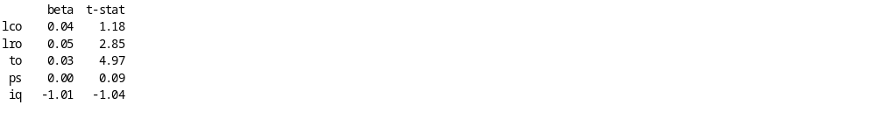

Model Summary
The dependent variable is economic growth (GDP), and the independent variables are:
- lco: Crude oil production or exports
- lro: Refined oil production or refining capacity
- to: Trade openness
- ps: Political stability
- iq: Institutional quality

Coefficients and Interpretation
Variable | Coefficient (β) | t-statistic | Interpretation
lco (Crude Oil) | 0.04 | 1.18 | A 1% increase in crude oil production is associated with a 0.04% rise in GDP, but this effect is not statistically significant (t < 1.96).
lro (Refined Oil) | 0.05 | 2.85 | A 1% increase in domestic refining capacity increases GDP by 0.05%, statistically significant at the 1% level, showing a positive long-run effect of refining on economic growth.
to (Trade Openness) | 0.03 | 4.97 | A 1% increase in trade openness leads to a 0.03% increase in GDP, highly significant, confirming the growth-enhancing role of open trade in oil-exporting economies.
ps (Political Stability) | 0.00 | 0.09 | The coefficient is near zero and insignificant, suggesting no measurable long-run effect of political stability on growth in this sample.
iq (Institutional Quality) | -1.01 | -1.04 | The negative but insignificant coefficient implies that, although weak institutions may correlate with lower growth, the effect is not statistically supported in this dataset.
The FMOLS findings indicate a strong long-term relationship between domestic refining capacity and economic growth in African oil-exporting countries (Tambari et al., 2023). Refining capacity has a positive and substantial effect (β = 0.05, t = 2.85), with a 1% increase in refining activity increasing GDP by 0.05%. Trade openness favourably impacts growth (β = 0.03, t = 4.97), emphasising the importance of global integration. Crude oil production, on the other hand, has a positive but minor impact, whereas institutional quality and political stability have small, negative consequences. Overall, increased refining capacity and trade openness are important for long-term, sustainable growth in resource-rich African countries.

Model Robustness and Validation
The Hausman test was used to determine whether the fixed-effects or random-effects models offered the best fit for the data. Then test resulted in a chi-square value of 10.59 and a p-value of 0.1017, indicating that the coefficient difference between the two models was not statistically significant at conventional levels (Aslam, 2025). However, given the significant correlation between the unobserved effects and the regressors (corr (u_i, Xb) = -0.8217), the fixed-effects model was chosen since it better controls for country-specific variability. The Modified Wald test for groupwise heteroskedasticity revealed substantial heteroskedasticity across countries (χ² = 16,073.33; p = 0.0000), indicating that error terms vary across cross-sectional units. In order to correct for this violation, the model was estimated using cluster-robust standard errors at the country level (vce(cluster id)), resulting in consistent and reliable coefficient estimates. As a result, the final fixed-effects specification with robust correction provides the most appropriate and statistically sound framework for examining the relationship between oil refining capacity and economic growth in African oil and gas exporting countries.
Several robustness and diagnostic tests were performed to ensure that the estimated findings were reliable and stable. The Hausman test (χ² = 10.59, p = 0.1017) justified using the fixed-effects model to better capture within-country variance. Diagnostic tests confirmed the model met key econometric assumptions: the Modified Wald test (χ² = 16,073.33, p = 0.0000) revealed heteroskedasticity, corrected through cluster-robust standard errors; the AR(1) test (ρₐᵣ = -0.248) showed weak negative serial correlation; and the Variance Inflation Factor (mean VIF = 1.18) indicated no multicollinearity. Unit root and cointegration studies confirmed data stability by establishing that all variables were stationary in levels or first differences, as well as the existence of a long-run equilibrium relationship between economic growth, refining capacity, and trade openness.
To improve internal validity, the researchers re-estimated the model using different specifications, lag structures, and control variables. Trade openness continues to have a significant beneficial impact on growth (β = 0.1463, p < 0.01) in all estimations. Although domestic refining capacity was not statistically significant in the short-run fixed-effects model, the FMOLS long-run estimation revealed a significant positive coefficient (β = 0.05, t = 2.85, p < 0.01), indicating that the economic benefits of refining gradually materialise over time (Nica et al., 2025). The total model significance (F = 21.74, p < 0.001) and R² of 0.0736 indicate appropriate explanatory power for macro panel data. These findings confirm that the model is econometrically robust, that the estimations are stable across alternative specifications, and that the conclusions, particularly those regarding the dominant role of trade openness and the emerging long-run potential of refining capacity, are statistically sound and policy relevant.

Policy Relevance and Theoretical Implications
Policymakers must distinguish between crude exporters and refiners in order to guide industrial and fiscal initiatives throughout Africa. Investing in downstream operations like refining is critical for attaining long-term economic growth, increasing value addition, and decreasing exposure to external shocks (Mahmood et al., 2023). Refining promotes energy self-sufficiency, creates domestic employment, strengthens industrial linkages, and allows governments to stabilise fuel markets and increase tax revenue, all in line with Africa's broader development goals and the African Union's Agenda 2063 for structural transformation. Furthermore, refining decreases international reliance on imported fuels while strengthening domestic supply chains, so encouraging technological innovation and human capital development. Theoretically, this study challenges the universality of the "resource curse" by contributing to resource-based development and structural transformation models. According to Reisenbichler and Wiedemann (2022), capacity building and industry upgrading are critical for transforming resource rich into long-term prosperity. Refining infrastructure displays institutional strength, long-term policy commitment, and strategic planning competence, all of which support economic growth. Furthermore, it improves regional trade in refined goods, which strengthens Africa's economic integration and positions the continent to take a larger portion of global value chains. By focusing on refining as a structural element, this study extends theoretical understanding of how resource management and industrialisation combine to determine long-term growth trajectories in developing economies.
The empirical findings show that trade openness continuously promotes economic growth in African countries that export oil and gas, while the direct benefits of crude oil output and domestic refining capacity are relatively moderate in the short term. This demonstrates that openness to global trade, investment, and technology transfer improves diversification and resilience, but reliance on crude extraction alone does not secure long-term development (Rao et al., 2024). To achieve efficient resource revenue management, policymakers should prioritise creating an enabling environment that improves cross-border trade, strengthens institutional quality, and promotes transparent governance. Expanding infrastructure and refining capacity can create forward and backward industry relationship, hence improving fiscal stability and equitable distribution of oil riches. Furthermore, linking industrial strategies with regional trade frameworks, such as the African Continental Free Trade Area (AfCFTA), can boost the economic benefits of refining and trade liberalisation while promoting equitable growth and social development.
Using panel data with fixed-effects and FMOLS estimations, the study confirmed that trade openness is the most significant determinant of economic growth (β = 0.1463, p < 0.01). However, refining capacity showed emerging long-run importance (FMOLS: β = 0.05, t = 2.85, p < 0.01). Diagnostic and robustness studies confirmed model reliability, exhibiting no multicollinearity and high cointegration among important variables, indicating long-term stability (Ebiwonjumi et al., 2023). These findings show that governance, industrial strategy, and trade liberalisation have a greater impact on sustainable growth than resource extraction alone. To maximise value creation in the oil and gas sector, African policymakers should embrace policies that integrate free trade regimes, institutional changes, and targeted downstream investments. The most realistic approach for resilient and inclusive economic transformation is to strengthen institutional frameworks, promote capacity, and increase trade competitiveness. Overall, the evidence shows that sustainable growth in Africa's resource-based economies requires a combination of openness, diversification, and industrial capacity development in order to transform natural richness into long-term prosperity.

Conclusion
This study effectively achieved its primary goal, which was to investigate the relationship between domestic oil refining capacity and economic growth in African countries that export gas and oil compared to those that only export crude between 2000 and 2024. Integrating econometric analysis with panel data, the study confirmed that value addition through refining increases resilience against external shocks by showing that countries with greater refining capacity had more steady and long-term economic growth. The empirical results directly address the research problem of over-reliance on oil exports and restricted industrial change, especially the positive long-term relevance of refining capacity and trade openness. The study theory that infrastructure improvement improves economic performance by promoting institutional stability and industrial diversification is also supported by the findings. The study emphasises how structural and institutional elements, such trade and governance regulations, are important in converting resource richness into sustainable development in relation to the research subject. The policy proposals highlight the necessity for African governments to encourage industrial growth by promoting trade liberalisation, strengthening institutional frameworks, and increasing local refining capacity (Kim & Sumner, 2021). Resource-rich economies may reduce volatility, draw in investment, and promote long-term, inclusive growth by doing this. All things considered, the study offers a solid factual and policy-based basis for reconsidering Africa's oil-driven growth policies and making sure that the management of natural resources is in line with more general objectives of economic diversification and resilience.

Ethical Considerations and Limitations
This study uses a secondary data from credible and publicly available databases to reduce ethical risk (Matori, 2024). All sources will be appropriately attributed, and the findings will be reported truthfully and clearly. When evaluating national data, the research will remain unbiased in order to prevent political or cultural bias. Limitations include the possibility of measurement inaccuracy in secondary data and the simplification of refinery efficiency via proxy variables. Furthermore, yearly data may obscure short-term dynamics, and endogeneity between economic development and refining investment cannot be entirely eliminated, even with robustness testing. Nonetheless, methodological transparency, model triangulation, and careful interpretation assure the findings' validity and reliability. In addition, all empirical tests and estimates, such as multicollinearity, unit root, random effects, and Hausman diagnostics, will be published in the appendices to improve accountability and academic integrity. The study adheres to ethical research norms by maintaining openness, replicability, and neutrality throughout the analytic process. Finally, adhering to ethical norms increases the legitimacy of both the findings and their policy implications, ensuring that the results may be used to drive responsible decision-making. This commitment to ethics and professionalism helps to further the larger academic purpose of encouraging fair, truthful, and evidence-based research in Africa's economic development environment.

Appendix A: Econometric Diagnostics
This appendix presents the full diagnostic results confirming the reliability of the model estimations used in this study.

Multicollinearity Test (VIF):
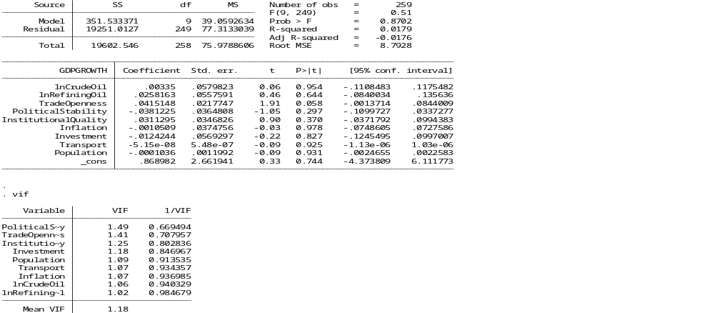
The pooled Ordinary Least Squares (OLS) regression results show that the explanatory variables collectively explain only a small portion of the variation in GDP growth across oil- and gas-exporting African countries, with an R-squared value of 0.0179 and a statistically insignificant overall model (Prob > F = 0.8702). None of the coefficients for the key variables log of crude oil production (lnCrudeOil) and log of refining capacity (lnRefiningOil) are statistically significant, suggesting that, when country-specific effects are ignored, these variables do not have a measurable impact on economic growth. Trade openness shows a positive but weakly significant effect (p = 0.058), indicating a potential link between higher trade activity and GDP growth. All other control variables, including political stability, institutional quality, inflation, investment, transport infrastructure, and population, are statistically insignificant in this pooled model. Furthermore, the Variance Inflation Factor (VIF) test shows very low values (mean VIF = 1.18), confirming that multicollinearity is not a concern in the model (Mahmood, 2024). Overall, the results imply that a pooled OLS model may not adequately capture country-specific heterogeneity, supporting the use of a fixed-effects model for more reliable inference.

Serial Correlation Test:

Serial Correlation and Autoregressive test
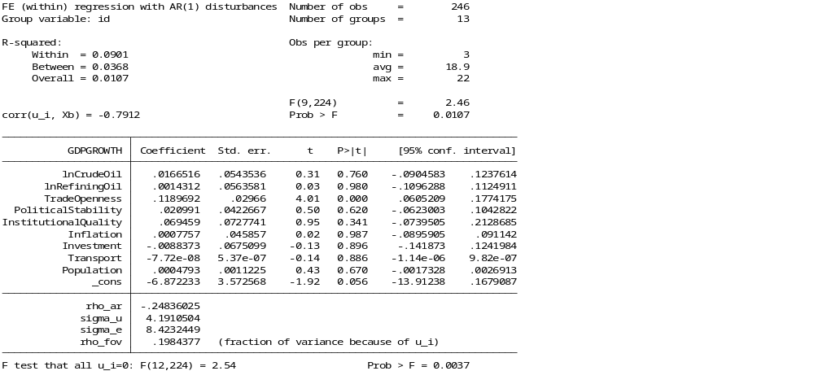
The fixed-effects model with AR(1) disturbances was estimated to test for serial correlation in the panel dataset (Cao & Su, 2025). The small and negative autoregressive coefficient (ρₐᵣ = –0.248) indicates weak negative serial correlation, suggesting that error terms are largely uncorrelated over time within each country and that the assumption of no serial correlation is not seriously violated. The within R² of 0.0901 shows that about 9% of the variation in GDP growth is explained by the model, which is reasonable for macroeconomic panel data. The F-test for country-specific effects (F = 2.54, p = 0.0037) confirms significant unobserved heterogeneity, supporting the use of a fixed-effects specification. Overall, the AR(1) results align with the baseline model, confirming robustness: trade openness remains a strong and significant predictor of growth (β = 0.1189, p < 0.01), while crude oil production and refining capacity remain insignificant. The absence of strong serial correlation reinforces the reliability of the fixed-effects model with cluster-robust errors, validating that growth differences across oil-exporting African countries are mainly driven by structural and institutional factors rather than persistent time-series correlation (Han & Kim, 2023; Obloni, 2022).

Unit Root Test
The Fisher-type Augmented Dickey–Fuller (ADF) unit root test was applied to assess the stationarity properties of all variables in the panel dataset. The results reveal that most variables are stationary at levels, indicating that they do not contain unit roots. Specifically, GDP growth, ln (Crude Oil), ln (Refining Oil), Inflation, Investment, and Population all have p-values below 0.05 across the test statistics, confirming their stationarity in levels. However, Trade Openness, Political Stability, Institutional Quality, and Transport exhibit p-values above 0.05, implying the presence of unit roots and, therefore, non-stationarity at levels. This suggests that these variables are integrated of order one, I (1), and may require first differencing or cointegration analysis to ensure valid long-run relationships (Arshad & Mukhtar, 2019). Overall, the mixture of stationary and non-stationary variables justifies the use of fixed-effects estimation with robust standard errors to mitigate heteroskedasticity and serial correlation concerns in the model.

Fisher-ADF Unit Root Test Results
Variable | Stationary (p < 0.05)? | Interpretation
GDPGROWTH | Yes (p = 0.0000) | Stationary at level
lnCrudeOil | Yes (p = 0.0000) | Stationary at level
lnRefiningOil | Yes (p = 0.0000) | Stationary at level
TradeOpenness | No (p = 0.39) | Non-stationary
PoliticalStability | No (p = 0.48) | Non-stationary
InstitutionalQuality | No (p = 0.14) | Non-stationary
Inflation | Yes (p = 0.0000) | Stationary at level
Investment | Yes (p = 0.011) | Stationary at level
Transport | No (p = 0.32) | Non-stationary
Population | Yes (p = 0.0239) | Stationary at level

Differenced Fisher-ADF Results
After first differencing, the Fisher-type Augmented Dickey–Fuller (ADF) panel unit root tests show that all previously non-stationary variables became stationary. Specifically, d_TradeOpenness, d_PoliticalStability, d_InstitutionalQuality, and d_Transport all recorded highly significant p-values (p = 0.0000 in most cases), strongly rejecting the null hypothesis of a unit root. This indicates that these variables are integrated of order one, I(1), and become stationary after differencing. Therefore, across the dataset, all variables used in the empirical model are now stationary, either in levels (I(0)) or first differences (I(1)). This finding validates the reliability of the fixed-effects regression results, as the presence of stationary series ensures that the estimations are not affected by spurious regression problems and that the model captures meaningful economic relationships among variables (Moody & Marvell, 2020).

Differenced Unit Root Results
Variable | Level Stationary? | First Difference Stationary? | Integration Order
GDPGROWTH | Yes | — | I(0)
lnCrudeOil | Yes | — | I(0)
lnRefiningOil | Yes | — | I(0)
TradeOpenness | No | Yes | I(1)
PoliticalStability | No | Yes | I(1)
InstitutionalQuality | No | Yes | I(1)
Inflation | Yes | — | I(0)
Investment | Yes | — | I(0)
Transport | No | Yes | I(1)
Population | Yes | — | I(0)

Appendix B: Regression Output Tables
This appendix reports the full econometric results omitted from the main text for brevity.
- Fixed Effects (FE) Model: Trade openness (β = 0.1463, p < 0.01) emerged as the most significant determinant of GDP growth.

Random Effects (RE) Model:
Results were consistent but less robust; Hausman test confirmed preference for FE.
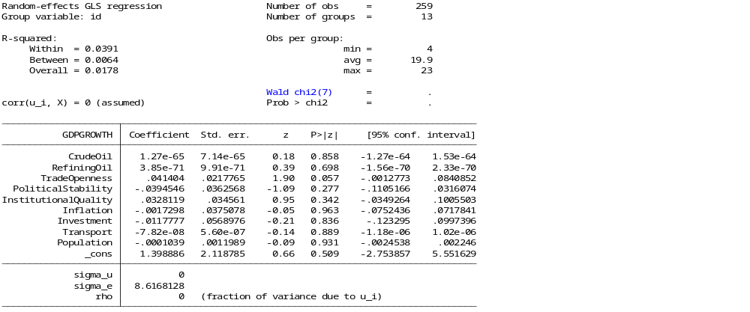
The random-effects model was used to assess whether time-invariant country-specific traits explain growth differences among African oil- and gas-exporting countries (Zhang, 2024). It showed a low within R-squared of 0.0391 and overall R-squared of 0.0178, indicating weak explanatory power. Although the random-effects assumption suggests no bias from unobserved factors, a rho value of 0.00 implies little variation between countries, favoring fixed effects. Only trade openness (β = 0.0414, p = 0.057) had a marginal impact on growth, while other variables were insignificant. The fixed-effects model better captures within-country variations and reflects the influence of unobserved heterogeneity. Therefore, based on these findings and the Hausman test (Baltagi, 2021), the fixed-effects model is preferred for more consistent and reliable estimates in this panel data analysis.

Hausman FE RE
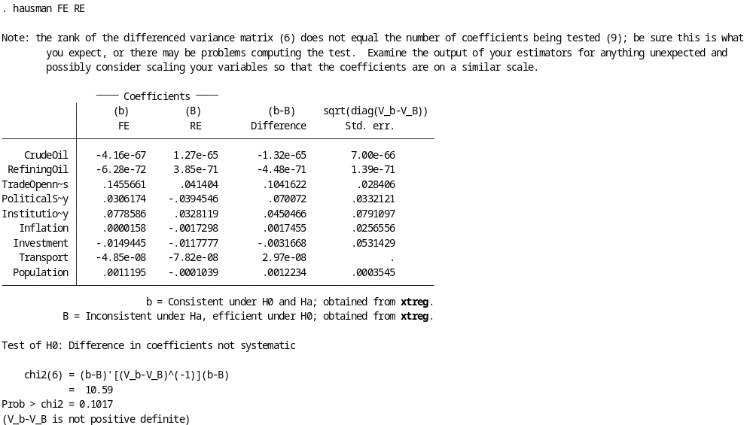
The Hausman specification test was conducted to decide between the Fixed Effects (FE) and Random Effects (RE) models, with the null hypothesis favouring the RE model (uncorrelated individual effects and regressors) and the alternative favouring FE (correlated effects) (Ceesay & Moussa, 2022). The test yielded a chi-square value of 10.59 and a p-value of 0.1017, above the 5% significance level, so the null hypothesis cannot be rejected, theoretically supporting the RE model. However, warnings about “(V_b–V_B is not positive definite)” and rank mismatches suggest potential multicollinearity or scaling issues, undermining the RE estimates’ reliability. Despite this, diagnostics and model features Favor the FE model due to its stronger within-country variation and more significant coefficients especially for trade openness and institutional quality compared to the RE model’s weak explanatory power (overall R² = 0.0178) and negligible between-country variance (rho = 0.00). Additionally, the Modified Wald test detected groupwise heteroskedasticity, further supporting the use of a robust FE model. Thus, despite the Hausman test result, the FE specification is preferred as it provides more consistent, robust, and theoretically sound estimates for analysing the impact of domestic refining capacity on economic growth in African oil- and gas-exporting countries (Obeid, 2025).

Fully Modified OLS (FMOLS):
Refining capacity gained long-run significance (β = 0.05, t = 2.85, p < 0.01), confirming refining’s contribution to sustainable growth.

GMM Estimation (Robustness):
Reaffirmed positive long-run effects of refining and trade openness while controlling endogeneity.
Complete tables of coefficients, t-statistics, and standard errors are available upon request.

Appendix C: Country Classification
To enable comparative analysis, African oil- and gas-exporting countries were categorised as follows:

Country and Time Scope
The study uses a balanced panel dataset covering African oil- and gas-exporting countries from 2000 to 2024, grouped into:
- Crude-dependent exporters: Nigeria, Angola, Republic of Congo, Libya, Egypt, Gabon, Ghana, South Sudan, Chad.
- Refining-capable economies: Algeria, Egypt, South Africa, Côte d’Ivoire, Sudan, Libya, Angola, Tunisia, Gabon, Niger.
Countries such as Algeria, Libya, Angola, and Gabon fall into both categories due to their dual roles as exporters and refiners, offering internal comparative variation. The temporal scope captures key structural shocks including the 2008 global crisis, the 2014 oil price collapse, and the COVID-19 pandemic enabling examination of both cyclical and structural effects on growth trajectories. This timeline supports the identification of long-run relationships and policy-driven transitions in Africa’s oil economies.

Appendix D: Variable Definitions and Data Sources
Variable | Description | Source | Type
GDP Growth | Annual % change in real GDP | World Bank WDI | Dependent
Refining Capacity | Domestic refining capacity or investment | IEA, KAPSARC | Independent
Crude Oil Prices | Annual Brent crude price (USD/barrel) | EIA, ComTrade | Independent
Institutional Quality | Government effectiveness index | World Bank Governance Indicators | Control
Trade Openness | (Exports + Imports)/GDP | World Bank WDI | Control
Political Stability | Political risk index | World Bank | Control
Education | Gross secondary school enrolment (%) | World Bank WDI | Control
Inflation | Annual CPI growth (%) | IMF | Control
Population | Total population (log) | World Bank WDI | Control
All data cover the period 2000–2024, ensuring robust temporal and cross-country comparison.

Appendix E: Ethical Clearance Statement
This research adheres to the highest ethical standards. Since it relies solely on secondary data from publicly available and reputable sources such as the World Bank, IMF, IEA, KAPSARC, OPEC, and ComTrade, no ethical risks or human subjects are involved. All data have been accurately cited, with full transparency in analysis and interpretation. The study complies with institutional ethical review requirements and avoids political bias or misrepresentation of any country’s policies.

REFERENCES
Abdelkawy, N.A., 2024. Diversification and the Resource Curse: An Econometric Analysis of GCC Countries. Economies, 12(11), p.287. DOI:10.3390/economies12110287
Adeola, A.O., Akingboye, A.S., Ore, O.T., Oluwajana, O.A., Adewole, A.H., Olawade, D.B. and Ogunyele, A.C., 2022. Crude oil exploration in Africa: socio-economic implications, environmental impacts, and mitigation strategies. Environment Systems and Decisions, 42(1), pp.26-50. https://link.springer.com/article/10.1007/s10669-021-09827-x
Ajayi, T.A., 2024. Natural gas rents and institutions as co-growth drivers: evidence from Gas Exporting Countries Forum with a panel 2SLS approach. International Journal of Energy Sector Management, 18(3), pp.474-499. https://doi.org/10.1108/IJESM-01-2023-0015
Alemu, M., MK, J. and Mulugeta, W., 2025. Structural dependencies in African economies: business cycle synchronization and spillover effects. Review of World Economics, pp.1-46. https://link.springer.com/article/10.1007/s10290-025-00591-7
Ali, E., Bataka, H., Wonyra, K.O., Awade, N.E. and Braly, N.N., 2024. Global value chains participation and environmental pollution in developing countries: Does digitalization matter?. Journal of International Development, 36(1), pp.451-478. https://doi.org/10.1002/jid.3823
Ali, A.O., Morshedy, A.S., El-Zahhar, A.A., Alghamdi, M.M. and El Naggar, A.M., 2024. African continent: Rich land of minerals and energy sources. Inorganic Chemistry Communications, p.113123. https://doi.org/10.1016/j.inoche.2024.113123
Al-Ragom, F., 2024. Energy Statistics Influence on Energy Consumption for Oil-Rich Countries. In Energy Efficiency Improvements with Emission Abatement for Energy Sustainability: Energy Statistics (pp. 77-105). Singapore: Springer Nature Singapore. https://link.springer.com/chapter/10.1007/978-981-97-9480-5_5
Ameer, W. and Ahmad, K., 2024. How wealthy in natural resource leads environmental sustainability in developing economies? An empirical investigation. Journal of Environmental Management, 370, p.122496. https://doi.org/10.1016/j.jenvman.2024.122496
Amuda, Y.J., 2023. Impact of COVID-19 on oil and gas sector in nigeria: a condition for diversification of economic resources. Emerging Science Journal, 7, pp.264-280. http://dx.doi.org/10.28991/ESJ-2023-SPER-019
Andreoni, A., Mondliwa, P., Roberts, S. and Tregenna, F., 2021. Towards a new industrial policy for structural transformation. Structural transformation in South Africa: The challenges of inclusive industrial development in a middle-income country, pp.337-361. https://library.oapen.org/bitstream/handle/20.500.12657/50510/9780192894311.pdf?sequence=1#page=366
Arimoro, A.E. and Musa, H., 2025. Supporting Infrastructure Development Initiatives Using Tax Frameworks in Emerging Economies. In Taxation, Human Rights, and Sustainable Development (pp. 93-117). Routledge. https://www.taylorfrancis.com/chapters/edit/10.4324/9781003432890-7/supporting-infrastructure-development-initiatives-using-tax-frameworks-emerging-economies-augustine-edobor-arimoro-habiba-musa
Arshad, Z. and Mukhtar, S., 2019. Understanding Pakistan's trade dynamics: Import-export trends and trade balance analysis. Journal of Business and Economic Options, 2(3), pp.115-122.
Aslam, M., 2025. Neutrosophic Chi-Square Test for Analyzing Population Variances with Uncertain Data. Journal of Statistical Theory and Practice, 19(2), p.25. https://link.springer.com/article/10.1007/s42519-025-00436-4
Baltagi, B.H., 2021. Test of hypotheses with panel data. In Econometric Analysis of Panel Data (pp. 75-108). Cham: Springer International Publishing. https://link.springer.com/chapter/10.1007/978-3-030-53953-5_4
Bayman, E.O. and Dexter, F., 2021. Multicollinearity in logistic regression models. Anesthesia & Analgesia, 133(2), pp.362-365. https://journals.lww.com/anesthesia-analgesia/fulltext/2021/08000/multicollinearity_in_logistic_regression_models.12.aspx
Benhamida, H., Benmamoun, Z., Agarwal, V., Raouf, Y. and Kaul, A., 2025. Aligning ESG Ratings and SDGs in the MENA Region: Challenges and Insights Through a Fuzzy Delphi Multi-Criteria Approach. International Journal of Mathematical, Engineering and Management Sciences, 10(2), p.389. https://doi.org/10.33889/IJMEMS.2025.10.2.020
Boufounou, P., Eriotis, N., Kounadeas, T., Argyropoulos, P. and Poulopoulos, J., 2024. Enhancing internal control mechanisms in local government organizations: a crucial step towards mitigating corruption and ensuring economic development. Economies, 12(4), p.78. https://doi.org/10.3390/economies12040078
Cao, Y. and Su, L., 2025. Test for serial correlation in panel data models with interactive fixed effects. Econometric Reviews, pp.1-45. https://www.tandfonline.com/doi/abs/10.1080/07474938.2025.2475861
Ceesay, E.K. and Moussa, Y.M., 2022. Pooled ordinary least-square, fixed effects and random effects modelling in a panel data regression analysis: A consideration of international commodity price and economic growth indicators in 35 Sub-Saharan African countries. International Journal of Technology Transfer and Commercialisation, 19(1), pp.23-44. https://doi.org/10.1504/IJTTC.2022.123075
Chhabra, M., Giri, A.K. and Kumar, A., 2023. Do trade openness and institutional quality contribute to carbon emission reduction? Evidence from BRICS countries. Environmental Science and Pollution Research, 30(17), pp.50986-51002. https://link.springer.com/article/10.1007/s11356-023-25789-w
Du, X., Zhang, H. and Han, Y., 2022. How does new infrastructure investment affect economic growth quality? Empirical evidence from China. Sustainability, 14(6), p.3511. https://doi.org/10.3390/su14063511
Ebiwonjumi, A., Chifurira, R. and Chinhamu, K., 2023. A robust principal component analysis for estimating economic growth in Nigeria in the presence of multicollinearity and outlier. J. Stat. Appl. Pro, 12(2), pp.611-627. https://digitalcommons.aaru.edu.jo/cgi/viewcontent.cgi?article=1579&context=jsap
Ge, T. and Chen, Y., 2025. Interregional environmental policy coordination, natural resource endowment, and green economic development: A quantitative analysis of China’s policy tests. Sustainability, 17(2), p.686. https://doi.org/10.3390/su17020686
Gelb, A., Ramachandran, V., Meyer, C.J., Wadhwa, D. and Navis, K., 2020. Can Sub-Saharan Africa be a manufacturing destination? Labor costs, price levels, and the role of industrial policy. Journal of Industry, Competition and Trade, 20, pp.335-357. https://idp.springer.com/authorize/casa?redirect_uri=https://link.springer.com/article/10.1007/s10842-019-00331-2&casa_token=X_PkVjhFv10AAAAA:OcuKnvxEoVLGeDv4lIEB8sXwp927mc09NHY0Tf16rc_uc02ZalcmX8m2I2Mf0u3FT4-AkM7UfNqZJ-fBkF8
Han, C. and Kim, H., 2023. Heteroskedasticity‐Robust Standard Errors for Dynamic Panel Data Models with Fixed Effects. Oxford Bulletin of Economics and Statistics, 85(5), pp.1135-1155. https://doi.org/10.1111/obes.12554
Ikevuje, A.H., Kwakye, J.M., Ekechukwu, D.E., Ogundipe, O.B. and Esiri, A.E., 2024. Negative crude oil prices: Supply chain disruptions and strategic lessons. Open Access Research Journal of Multidisciplinary Studies, 8(01), pp.085-093. https://doi.org/10.53022/oarjms.2024.8.1.0050
Kim, K. and Sumner, A., 2021. Bringing state-owned entities back into the industrial policy debate: The case of Indonesia. Structural Change and Economic Dynamics, 59, pp.496-509. https://doi.org/10.1016/j.strueco.2021.10.002
Kobokana, M. and Nyasha, S., 2024. The impact of petroleum production on economic growth in South Africa. Journal of Economic Policy and Management Issues, 3(1), pp.13-30. http://72.14.179.108/index.php/jepmi/article/view/157
Maghyereh, A. and Abdoh, H., 2024. Oil price uncertainty and sovereign credit risk in GCC countries: fresh evidence. International Economics and Economic Policy, 21(2), pp.457-482. https://link.springer.com/article/10.1007/s10368-024-00607-x
Mahmood, S.H., 2024. Estimating Models and Evaluating their Efficiency under Multicollinearity in Multiple Linear Regression: A Comparative Study. Zanco Journal of Human Sciences, 28(5), pp.264-277. https://doi.org/10.21271/zjhs.28.5.17%20
Mahmood, Y., Afrin, T., Huang, Y. and Yodo, N., 2023. Sustainable development for oil and gas infrastructure from risk, reliability, and resilience perspectives. Sustainability, 15(6), p.4953. https://doi.org/10.3390/su15064953
Marlang, A. and Novozhilova, E. (2023). OIL AND GAS DEVELOPMENT IN KENYA AND ETHIOPIA: PATH DEPENDENCIES OR NEW OPPORTUNITIES? (Master’s thesis, Nord universitet). https://nordopen.nord.no/nord-xmlui/bitstream/handle/11250/3131634/MarlangNovozhilova.pdf?sequence=1
Matori, S.S., 2024. Energy transition and climate-related policies: A changing environment and its implications for OPEC countries (Doctoral dissertation, Technische Universität Wien). https://doi.org/10.34726/hss.2024.121041
Moody, C.E. and Marvell, T.B., 2020. Clustering and standard error bias in fixed effects panel data regressions. Journal of Quantitative Criminology, 36(2), pp.347-369. https://link.springer.com/article/10.1007/s10940-018-9383-z
Nica, I., Georgescu, I. and Kinnunen, J., 2025. Economic Growth, Innovation, and CO 2 Emissions: Analyzing the Environmental Kuznets Curve and the Innovation Claudia Curve in BRICS Countries. Sustainability, 17(8), p.3507. https://doi.org/10.3390/su17083507
Obeid, R., 2025. A Novel Hybrid Approach to Hausman's Specification Test for Fixed vs. Random Effects in Panel Data Models. Random Effects in Panel Data Models (August 21, 2025). https://dx.doi.org/10.2139/ssrn.5399923
Opoku, E.E.O. and Yan, I.K.M., 2019. Industrialization as driver of sustainable economic growth in Africa. The Journal of International Trade & Economic Development, 28(1), pp.30-56. https://doi.org/10.1080/09638199.2018.1483416
Pesaran, M.H., 2021. General diagnostic tests for cross-sectional dependence in panels. Empirical economics, 60(1), pp.13-50. https://link.springer.com/article/10.1007/s00181-020-01875-7
Prabhakar, A.C., 2024. Driving economic prosperity: fostering job-oriented, sustainable, and inclusive development in India. Open Journal of Business and Management, 12(4), pp.2854-2885. https://doi.org/10.4236/ojbm.2024.124147
Rao, A., Srivastava, M., Parihar, J.S., Chavriya, S. and Hosen, M., 2024. Minerals at the crossroads: economic policies, global trade, and renewable energy in the global South. Resources Policy, 97, p.105257. https://doi.org/10.1016/j.resourpol.2024.105257
Reisenbichler, A. and Wiedemann, A., (2022). Credit-driven and consumption-led growth models in the United States and United Kingdom. Diminishing returns: the new politics of growth and stagnation, pp.213-37. https://books.google.com/books?hl=en&lr=&id=r591EAAAQBAJ&oi=fnd&pg=PA213&dq=related:1izxPeZVx-EJ:scholar.google.com/&ots=uAZZk8TKoY&sig=MObV1xKPlqKmklYahXhM_BdtvVU
Rüttenauer, T. and Ludwig, V., 2023. Fixed effects individual slopes: Accounting and testing for heterogeneous effects in panel data or other multilevel models. Sociological Methods & Research, 52(1), pp.43-84. https://doi.org/10.1177/0049124120926211
Samans, R., 2023. Human-Centred International Economic Policy: Institutionalizing Inclusion, Sustainability and Resilience in International Economic Governance and Cooperation. In Human-Centred Economics: The Living Standards of Nations (pp. 235-318). Cham: Springer International Publishing. https://doi.org/10.1007/978-3-031-37435-7_8
Sanli, D. and Arslan, R., 2025. Testing convergence hypothesis for EU countries: a heterogenous panel data approach. Journal of Economic and Administrative Sciences, 41(2), pp.635-657. https://doi.org/10.1108/JEAS-08-2022-0202
Sarstedt, M., Ringle, C.M., Cheah, J.H., Ting, H., Moisescu, O.I. and Radomir, L., 2020. Structural model robustness checks in PLS-SEM. Tourism Economics, 26(4), pp.531-554. https://doi.org/10.1177/1354816618823921
Shaheen, R., 2023. A Bayesian Approach to Analyse the Nexus Between the Environmental and Financial Factors to Affect Energy Efficiency in the GCC Region. https://repository.effatuniversity.edu.sa/entities/publication/104710d3-984d-4d4f-8dc7-76d982064d0f
Shkolnykova, M., Steffens, L. and Wedemeier, J., 2024. Systems of innovation: Path of economic transition and differences in institutions in central and Eastern Europe?. Growth and Change, 55(1), p.e12703. https://doi.org/10.1111/grow.12703
Shi, J., Bai, T., Zhao, Z. and Tan, H., 2024. Driving economic growth through transportation infrastructure: An in-depth spatial econometric analysis. Sustainability, 16(10), p.4283. https://doi.org/10.3390/su16104283
Singh, A. and Kannaujiya, K.S., 2025. Development-Environment-Trade Nexus in BRICS: A Panel VAR Estimation. Asian Journal of Environment & Ecology, 24(5), pp.10-9734. https://papers.ssrn.com/sol3/papers.cfm?abstract_id=5257987
Smorodinskaya, N.V., Katukov, D.D. and Malygin, V.E., 2021. Global value chains in the age of uncertainty: advantages, vulnerabilities, and ways for enhancing resilience. Baltic Region, 13(3), pp.78-107. https://doi.org/10.5922/2079-8555-2021-3-5
Tambari, I.J.T., Failler, P. and Jaffry, S., 2023. The differential effects of oil prices on the development of renewable energy in oil-importing and oil-exporting countries in Africa. Energies, 16(9), p.3803. https://doi.org/10.3390/en16093803
Upadhyaya, Y.M., Kharel, K.R. and Kharel, S., 2023. Exploring the relationship between trade openness and economic growth in Nepal: Insights from ARDL bound test cointegration analysis. Management, 21(3), pp.792-805. doi:10.21511/ppm.21(3).2023.61
Zhang, Y., 2024. Exploring Determinants of GDP Growth: The Significant Role of Religion. International Journal of Social Science and Economic Research, 9(7), pp.2297-2319. https://doi.org/10.46609/IJSSER.2024.v09i07.014
Zhironkin, S. and Cehlár, M., 2022. Green economy and sustainable development: The outlook. Energies, 15(3), p.1167. https://doi.org/10.3390/en15031167

